Staff Forum
08.04.26

Attendees: Sarah Keane, Krissy Curnock (swale and canterbury), Dean Parker (DGS), Kath Cranley (Maidstone), Denise Scales (Sheppey), Jess Tolhurst (Office) and Shelley Lane (Events).

Apologies: Sonia Bassi (Thanet) and Syren Shand (Ashford/ Folkestone), Steve Dutton (DGS)

Zach:
Introduction/ welcome to Jess – new recruitment co Ordinator.
All staff signed the terms of reference and agreed to adhere to them.
Staff asked if they could have more notice for the next forum, for shift cover.
They were reminded to pop the date in their diaries as the date of each meeting is given at the end of each forum. July 8th is the next one, 3 months from today. Reminders to be put in the weekly Newsletter and Managers will be issued calendar invites to help with teams/ representatives planning ACTION.

Shelley: Events
Maidstone requested a spring watch pack of activities; the folders are kept in the houses. ACTION
Krissy will check Canterbury’s.
Shelley requested any photos for the display boards if service users give consent.
The cut off for the farm event was yesterday.
There will be a photography event next month on 16th May, held in Canterbury.
All will meet at station and will be going to different locations.
All attending can bring their own picnic and a camera; however, the photographer will have a camera if not.
The event will cost £10.
The next service user forum will be on 30th April, not many turned up to the last one.
Shelley asked staff encourage service users to come to the next one. ACTION
The SU forum will be held 12pm-3pm and the topic will be friendships and relationships.
Shelley is hoping to have the police in to do a talk on internet safety and the LD nursing team to speak about STI’s.
A few service users in relationships would like to talk about their relationships.
Shelley will send poster/questionnaire to Krissy.
Pool club is on the 1st Wednesday of every month.
Service users can bring their own packed lunch to Kent life, or there will be a café there.

Culture Steering Group:
Any support workers interested in joining please emails Zach. ACTION
This group was set up last year, the group have developed the PCAS values came the day in the life initiative, enhanced communication across the company and agreed on a new recognition process called Gestures of thanks – this will be launched soon. Service managers will be being to share gestures of thanks – watch this spa
This is a less formal way of saying thank you to staff for good. This works alongside the hero’s programme. Staff like the idea of smaller prizes/ gestures for each area, as well as having chance to win the larger recognition/ prize through PCAS Heroes.
It was mentioned that some people do not feel recognised, however all hero nominees receive a certificate of recognition.
Sheppey shared that they have their own PCAS Heroes.
All opportunities to recognise and celebrate great work is good to see. Localised/ area specific, or companywide.
Most staff agreed they prefer the communications through email instead of care control, so they can refer back to it if needed and zoom in.
Saheed has been creating fact sheets for the weekly update, if there are any specific conditions staff want Saheed to send out a factsheet on, please email training.
Dementia, autism and OCD will be handy.
HR also send out details of awareness days, menopause cafés and inclusion activities – keep your eyes peeled for updates where you can help spread the word.
It was mentioned care control is not showing staff pay, Zach will check this. ACTION

Training:
The co-trainers have received their certificates and will start to roll out training when they are compliant.
This will be in the office and will be mandatory training for all staff.
Staff must have completed part 1.
The training will depend on the service user training on the day.
Jess is gathering service use details, and all will help chase as some onboarding is still outstanding.

Action Plan:
Action 1. complete. The full PCAS values will be added to the terms of reference for the forum group.
Action 2. Representatives asked for a login guide to be developed to help all colleagues to access the website and minutes and action plans - not received, check with AM.
Note : Petrol money for mileage with the petrol prices going up, this will be forwarded on.
Note : The meeting is not showing on staff rotas. Managers to ensure that representatives are on the rota for attending he forum.
Action 3. Representatives asked if the events photos have been updated into the website, they had sent these through to Michelle - keep sending pictures to Michelle.
Shelley would like pictures for display boards and good news stories for the newsletter.
Action 4. A service user in Canterbury has written and published his own book – to be advertised in the newsletter – please don’t share this on social media but can we all spread the word.
Action 5. Update on the gestures of thanks – complete this will be in circulation soon .
Action 6. Outlined the business insurance guidance to be sent out. Some colleagues said they haven’t had this – contact Anne in HR for details.
Action 7. A representative asked if we can have a wellbeing day added on to our leave, so a paid wellbeing day each year, has been considered and this is not something the company can do due to the feasibility of this request.
Action 8. A representative asked if we have to check in to each shift, so on carecontrol we have multiple shifts, small shifts do we have to check in and out of them all especially in the same house, - sometimes we forget it would be easier if we could just check in to a location and not to a specific person – it was confirmed that you must put reason why on care control if late and yes staff must log in and log out for each service user.

Investigations:
There has been feedback that staff can feel like nothing has happened after reporting an incident, however Sarah reminded staff that things go on behind the scenes and HR work close with the managers to investigate. Not all outcomes will be known due to policy and confidentiality.

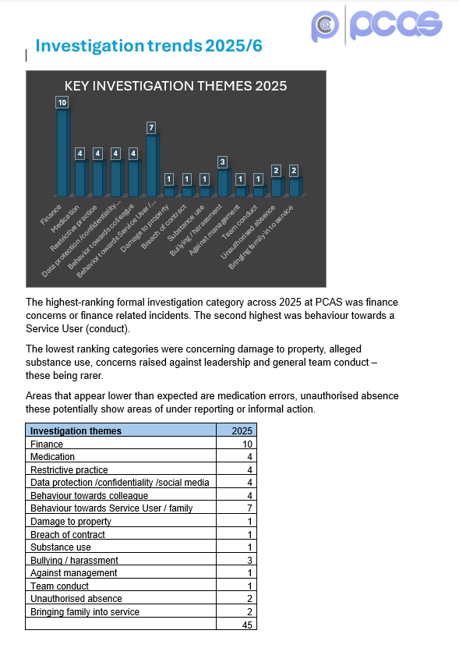

The highest number of investigations are finance related; staff are surprised by this.
Staff thought medication and behaviour would be higher, as they feel managers do not always report up.
If staff feel as if their complaint is not going anywhere, they should go higher if they need to and where needed use the whistleblowing process.
A summary of investigations over 2025 was outlined, totalling 45 formal investigations.
45 investigations is a lot and 7 is high for behaviour conduct concerns .
Service users’ volunteers will be in the interview process going forward, communication is important. And this will hopefully help with the standard and understanding that new staff have.
Service users will be bringing a list of questions to ask candidates.
Recruitment is also looking to move to localised job centred and community spaces. when there are vacancies.
Staff said most staff do not talk to the service users at events and get their phones out.
Induction and training is available for staff to learn.
Managers need to do more unannounced spot checks or HR drop ins.
Some staff may have 2 phones and watch films on their phone.
Probationary review needs to be used more effectively, and you all have a the ability to share constructive feedback whilst someone is on probation ( and beyond) as long as this is approached sensitively.
Phone use to be added into team meetings and the induction. ACTION

Survey:
The next Employee opinion survey will be going out soon, ideally in June, 6m months since the last full survey. Make sure you have your say. ACTION
Will look at responses in the survey to see what we have been doing well on and celebrate and also look at areas we can work on as a company.

Things to Celebrate:
Volunteers joining the recruitment process – this is going to be really good to help person centred support.
Sheppey service users going to Brighton on holiday, this will be their first holiday and Denise has sorted transport suitable for wheelchairs.
Canterbury service user taking medication without being prompted after not taking them.
Service user from Maidstone becoming a co-trainer.

Inclusion Calender:
May is antibullying month – we will share an update about this awareness day. Please take the opportunity to refresh the bullying and harassment policy on QCS. ACTION
World environmental day in June.
The photography competition will be in August.
HR to send inclusion calendar out again. ACTION

Update:
We raised £77 at the easter raffle for the umbrella community care charity.
Any ideas of events please let us know.

Company Update:
The directors are available for one to one’s after this meeting if needed.
Pay rise letters were sent out last week.
Still waiting for CQC to revisit, staff to be mindful they will revisit.
Not yet heard back regarding the internal audit.
KCC have done an audit, and it was a different outcome.

A Message from the Directors:
‘The last 12 months have been rather challenging for PCAS. As you’re all aware, we had the fallout of the CQC Inspection to deal with and it is with all of your hard work that we find ourselves in a much better position currently. We have requested that KCC remove the PP1 contract sanction entirely and we are hopeful that they’ll do this in the next few weeks. We are also hopeful that CQC may reinspect very soon and we’re confident that we can demonstrate significant improvements albeit, we need to make sure we sustain them and continue to improve.
The company has seen its most challenging financial year too. Focused reviews of the higher support packages and some unforeseen changes for people we support has led to an overall reduction in hours of in the region of 20%. This has come in times of additional funding pressures and KCC uplifts that don’t cover the full extent of our cost increases. The employer NI rise of last year has taken it’s toll on all providers but we took steps early on to mitigate some of this and you’ll have no doubt seen that there have been changes in the senior management. Suffice to say that we won’t be going anywhere and will remain in the day to day posts we have been covering. We have an excellent management team who are key to shaping the future at PCAS.
This last year has been stressful, challenging and extremely frustrating at times. But to move forwards, we need to take lessons from everything that’s happened and i think we’ve done that and will continue to learn.
We are starting to take new referrals so hopefully we can begin to grow again but it will be done cautiously and sustainably.
Thanks for everything you do and please remember a couple of important things:
If you see something that concerns you, report it.
If you have a question, ask it - we’re always happy to hear from you.
Michelle and Craig.’

AOB:
Staffed asked if they will receive petrol money, however staff do receive mileage costs. ACTION
Staff asked about easter bank holiday pay, can this also be time and a half. ACTION
2 staff have fallen down the stairs at Peel Street as the stairs blend into the floor ad have had serious injuries, these needs looking into. ACTION (Suggestions were tap on the floor or a rubber matt however the matt may slip).

Thanks for attending please make sure you get time to feedback in your next team meeting; the action plan will be attached to the minutes once ready.

The next forum will be the 8th of July – pop it in your calendar/ diaries.

